John Michael Go
Career Entry Level Java Programming
Date: Jan. 14, 2013

DAY 2

Program Name: Denomination

Objective: Program will calculate how many denomination from the inputted amount.

Algorithm:

- User inputs amount.
- Program will segregate amount into different denominations.

Flowchart:

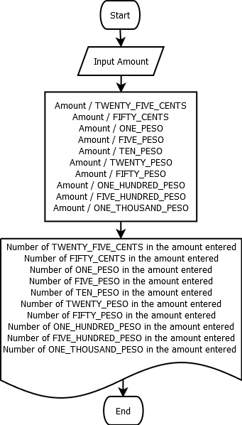

Pseudocode:

Pseudocode:

import java.util.*;
import java.io.*;

public class Denomination{
// static variable declaration
static Scanner console = new Scanner (System.in);
static final double TWENTY_FIVE_CENTS = .25;
static final double FIFTY_CENTS = .50;
static final double ONE_PESO = 1;
static final double FIVE_PESO = 5;
static final double TEN_PESO = 10;
static final double TWENTY_PESO = 20;
static final double FIFTY_PESO = 50;
static final double ONE_HUNDRED_PESO = 100;
static final double FIVE_HUNDRED_PESO = 500;
static final double ONE_THOUSAND_PESO = 1000;

public static void main(String[]args){

int Peso;
double a,b,c,d,e,f,g,h,i,j;

System.out.println("");
System.out.print("Input number in peso: "); // input number in peso
Peso = console.nextInt();
System.out.println("");
System.out.println("");
System.out.println ("===============================================================================");
System.out.println("");
// computation
a = (Peso / TWENTY_FIVE_CENTS);
b = (Peso / FIFTY_CENTS);
c = (Peso / ONE_PESO);
d = (Peso / FIVE_PESO);
e = (Peso / TEN_PESO);
f = (Peso / TWENTY_PESO);
g = (Peso / FIFTY_PESO);
h = (Peso / ONE_HUNDRED_PESO);
i = (Peso / FIVE_HUNDRED_PESO);
j = (Peso / ONE_THOUSAND_PESO);

// display computed value of denomination
System.out.println("Denomination:");
System.out.println("");
System.out.println("");
System.out.println(" .25 = There are " + String.format("%.2f", a) + " pieces of twenty five centavos in " + Peso);
System.out.println("");
System.out.println(" .50 = There are " + String.format("%.2f", b) + " pieces of fifty centavos in " + Peso);
System.out.println("");
System.out.println(" 1.00 = There are " + String.format("%.2f", c) + " pieces of one pesos in " + Peso);
System.out.println("");
System.out.println(" 5.00 = There are " + String.format("%.2f", d) + " pieces of five pesos in " + Peso);
System.out.println("");
System.out.println(" 10.00 = There are " + String.format("%.2f", e) + " pieces of ten pesos in " + Peso);
System.out.println("");
System.out.println(" 20.00 = There are " + String.format("%.2f", f) + " pieces of twenty pesos in " + Peso);
System.out.println("");
System.out.println(" 50.00 = There are " + String.format("%.2f", g) + " pieces of fifty pesos in " + Peso);
System.out.println("");
System.out.println(" 100.00 = There are " + String.format("%.2f", h) + " pieces of one hundred pesos in " + Peso);
System.out.println("");
System.out.println(" 500.00 = There are " + String.format("%.2f", i) + " pieces of five hundred pesos in " + Peso);
System.out.println("");
System.out.println(" 1,000.00 = There are " + String.format("%.2f", j) + " pieces of one thousand pesos in " + Peso);
System.out.println("");
System.out.println("");
System.out.println("");

}

}

Screenshot:

